URWERK And Contemporary Artist Cooper Jacoby
Join Forces In Supporting The Swiss Institute

Geneva November 3rd 2022.

"It represents the starting point for URWERK. The one that kicked it all off. It is celebrating its 25th birthday this year, just as URWERK itself is toasting its quarter-century of existence”, said Felix Baumgartner and Martin Frei. It stems from their very first collaboration, the UR-102 – definitely one of the models that triggers the most nostalgia and cravings among URWERK collectors. "It was a watch reserved for our first circle, our friends, our family members. Those who were the first ones to believe in us, so it is a highly emotional piece.”

The good news is that it will once again be in the spotlight on 10 December 2022, this time in a “reloaded” version. A unique piece, #1 of the UR-102 « reloaded » series.

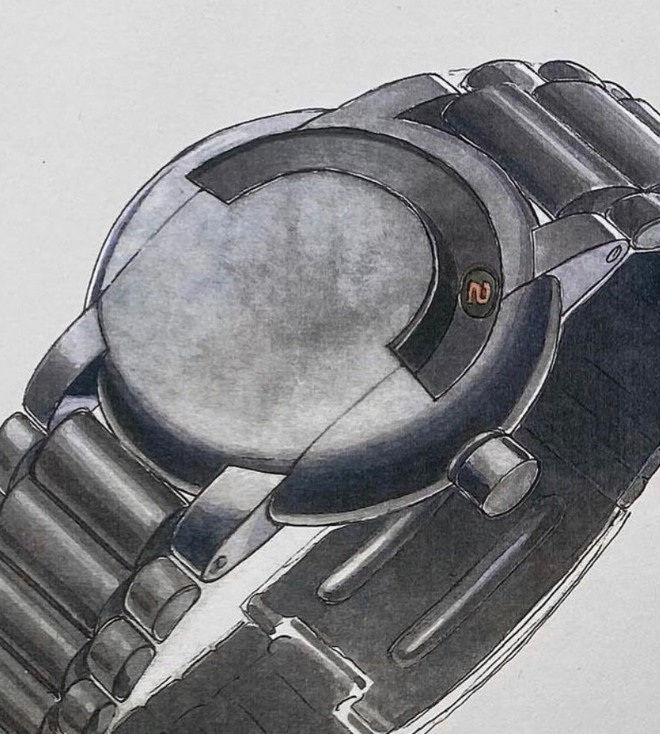

On 10 December 2022, in support of the emerging art scene, URWERK will dedicate a one-of-a-kind creation – the #1 of the UR-102 "reloaded" – to the Swiss Institute of New York.

The motivation behind this project is crystal clear. Martin Frei, chief designer and co-founder of URWERK expresses it best: "After graduating from the University of Arts and Applied Sciences in Lucerne, I started my creative journey in New York. With a few friends, we created the U.S.A. association (United Swiss Artists), an anchor point far from home, a point of fall or rather of support in difficult times. It is the same philosophy that I find in the approach of the Swiss Institute. Our involvement in this project was therefore self-evident»

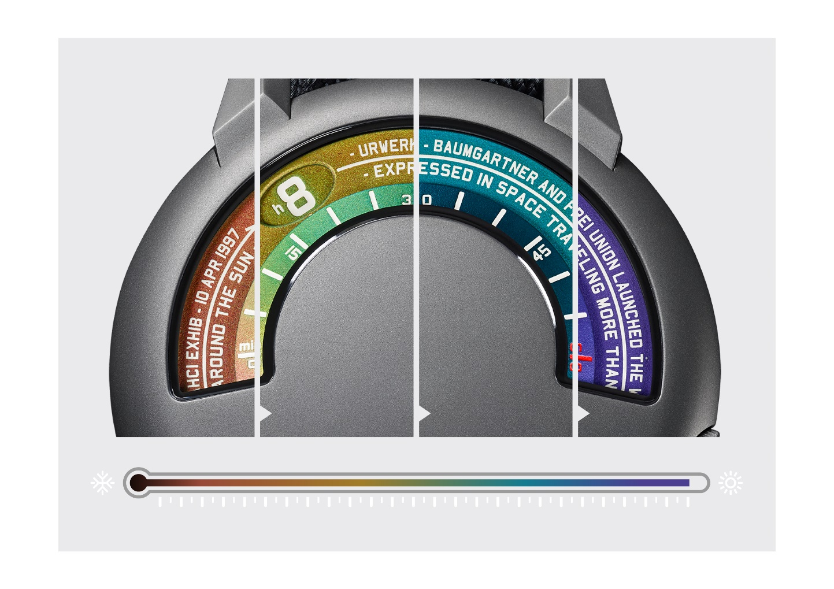

The #1 UR-102 « reloaded » will be auctioned under the auspices of Phillips. This single-piece edition stems from a collaboration with Cooper Jacoby, an American contemporary artist who reinterprets one of the most emblematic and decisive URWERK creations: the UR-102 in its new “reloaded” version. Jacoby is an up-and-coming artist who draws attention to the functionality of the systems governing our lives. Using innovative treatments of materials such as nickel, copper, rubber and silicon, the artist creates electrifying sculptures, transforming what is often left invisible into striking and vibrant perceptions.

In this instance, Jacoby revisits the notion of graduation. This first UR-102 "reloaded" displays a wandering hour that counts down time in both analog and digital formats. On the dial of this one-of-a-kind watch, Jacoby uses thermochromic pigments to embody one of the body's most essential regulatory systems: temperature. The dial of this UR-102 is thus transformed through a range of infinitely variable color tones, interacting with and changing in response to thermal variations. A ‘reloaded’ UR-102 immersed in a state of regular flux.

Engaged in a process of perpetual renewal, the Jacoby and URWERK creation marries the systemic precision of chronometry with the harmony of human biology.




01:48 pm ; hot lunch break in old-town
8:25 am ; fresh morning walk by the lake

Technical specifications
Cooper Jacoby x UR-102 “reloaded” one-of-a-kind creation

Movement
Calibre | 2.02
Winding | Automatic
Finishing | Satin-brushed
Frequency | 28,800 vph
Jewels | 25
Power reserve | 48 hours
Indications | Wandering hours appearing on engraved discs  Thermal colour index
Case | Case middle and lugs in titanium
Dimensions | Diameter: 41mm; thickness 11.30mm
Glass | Shaped sapphire crystal
Water resistance | Tested at 30m (3atm)
Strap | - Baltimora fabric strap  - Pin buckle in sandblasted titanium
Media contact | Ms Yacine Sar  press@urwerk.com  +41 22 900 2027  www.urwerk.com/press

TIME FOR ART
In December 2022, Swiss Institute introduces TimeForArt – the first-ever benefit watch auction to support contemporary art and artists. TimeForArt is a curated benefit auction of exceptional timepieces from the world’s greatest watchmakers, with 100% of the proceeds directly enabling today’s most visionary artists, through Swiss Institute’s exhibitions, public programs, education & community engagement workshops – all free of charge.

SWISS INSTITUTE
Swiss Institute (SI) is an independent non-profit contemporary art institution dedicated to promoting forward-thinking and experimental art making through innovative exhibitions, education, and programs. Committed to the highest standards of curatorial and educational excellence, SI serves as a platform for emerging artists, catalyzes new perspectives on celebrated work, and fosters appreciation for under-recognized positions. SI is committed to being an organization that is diverse, equitable, and accessible in its work, structure, and programming. Open to the public free-of-charge, Swiss Institute seeks to explore how a Swiss context can be the starting point for international conversations in the fields of visual and performing arts, design, and architecture.

URWERK
Founded in 1997 by Felix Baumgartner and Martin Frei, URWERK is the result of a strongly held belief that the history of Fine Watchmaking is a constantly changing art. Felix Baumgartner, a watchmaker like his father and grandfather, has time running through his veins. A graduate from the Schaffhausen watchmaking school, Felix learned the secret language of minute-repeaters, tourbillons and perpetual calendars at his father’s bench. Martin Frei is the artistic counterweight to his partner’s technical expertise. Accepted into the Lucerne’s college of art and design in 1987, Martin delved into every form of visual artistic expression from painting and sculpture to video, emerging as a mature artist. The two men met by chance and discovered a common fascination with the measurement of time, spending hours analyzing the gap between the watches they saw in the shops and the vision of their future creation: “Bringing out yet another version of an existing mechanical complication was not our aim,” the two explain. “Our watches are unique because each has been conceived as an original work. Above all, we want to explore beyond the traditional horizons of Haute Horlogerie.”

