The seven wonders of the UR-210

Geneva - June 16, 2020

URWERK will unveil the last edition of its iconic UR-210 on June 17, so now is the ideal time to highlight the seven features that have made the UR-210 so special:

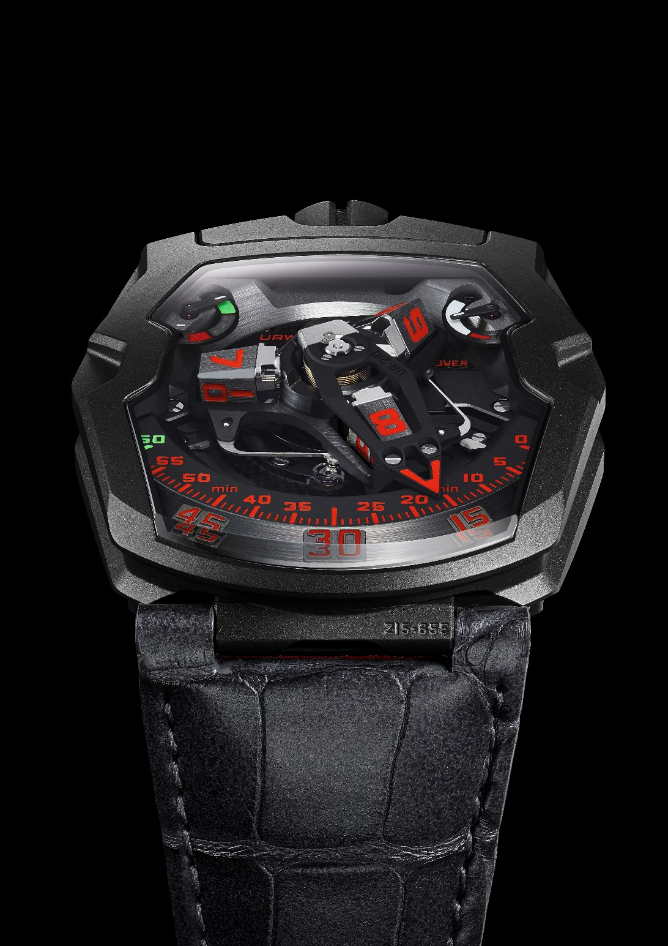

1. Marine chronometer inspiration
"To develop the UR-210 and ensure its precision and long term performance, I drew inspiration from the watchmaking culture that my father instilled in me," explains Felix Baumgarter. "My father Gerhard Baumgartner, a clock restorer renowned for his extensive knowledge and watchmaking skill, was my first teacher. Ever since I was five years old, I could enter his workshop to discover, and sometimes even touch, the antique mechanical masterpieces he was restoring. My superheroes were Thomas Thompion, Antide Janvier, Abraham Louis Breguet, and Ferdinand Berthoud. It’s thanks to what I learned as a child at my father’s side that URWERK today is at the forefront of innovation."

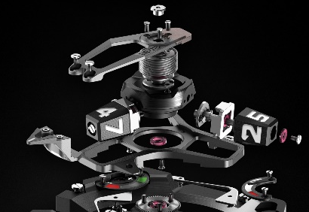

2. Retrograde system
The UR-210 has one of the largest retrograde systems available. "We wanted it to be oversized, to the limit of the possible. The UR-210 retrograde hand is a complex mechanism that docks with the hour satellites while indicating the minutes. The first tests were epic. The system was so extraordinary, and the force released so strong, that it overpowered the mechanics. We had to refine the system to find just the right compromise between power and speed to finalize the design. To appreciate the complexity of this movement in full, you must not only observe the minute hand fly back from 60 to 0, but listen to it too. It's the sharp "clack" it makes that signals the beginning of each new hour." Felix Baumgartner.

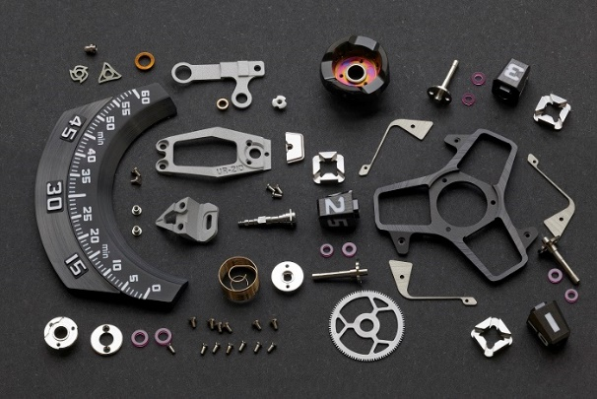
3. Winding efficiency
The UR-210 features an entirely new type of automatic winding efficiency indication that has been granted a patent. It indicates whether the user has generated enough power over the last two hours of use to keep the UR-210’s mainspring sufficiently wound. It is a very personal indication that changes with the wearer’s actions. The more you move, the more your watch displays appreciation by indicating green. This is a sentimental indication between the wearer and their watch. "I like the idea of ​​a fusional interaction between an owner and their watch. The UR-210 displays the time, provides a visual spectacle of its operation, and helps its wearer learn a little more about themselves: it’s a pedometer for the wrist." Martin Frei

4. Turbines
It is thanks to the UR-210 that URWERK has been able to refine and perfect our turbine regulation automatic winding system. The goal was to offer as much user control as possible by being able to select and refine the winding mode. "I started my career in the after-sales service of major watch brands and had to deal with recurring problems caused by the premature wear components, so we developed a system that minimized the problem. The turbines on the UR-210 are inspired by the regulators used in grande sonnerie movements." Felix Baumgartner

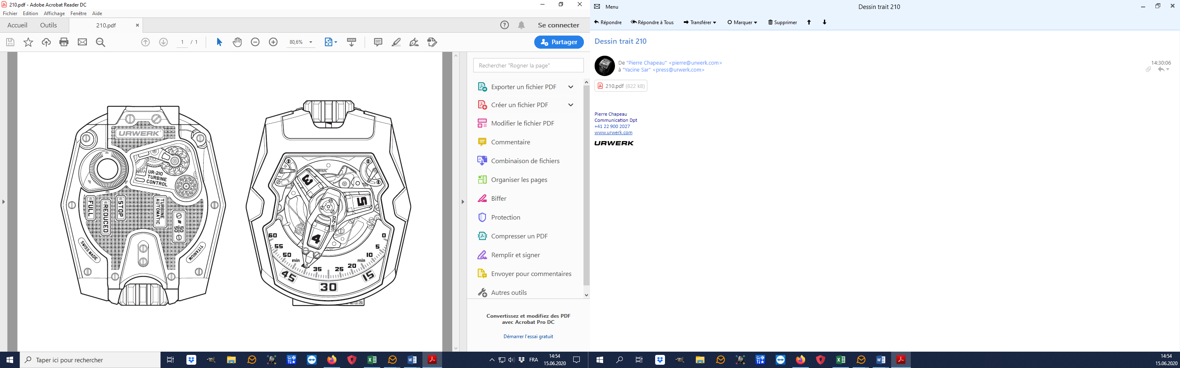

5. Aesthetics 1
"A protective band frames the complexly shaped sapphire crystal glass of the UR210 There is a certain amount of G-Shock in this design element. I like a three-dimensional topography of the case because it encourages both the eyes and hands to interact with it. The distinctive form empowers the case iconic character." Martin Frei

6. Aesthetics 2
The UR-210 is one of the most symmetrical pieces designed by URWERK. "All of our creations though have an organic character with irregularities and points of division. The UR-210 is architectural or sculptural in its construction, which reflects my interest and connection with the architectural firm I share my office with. The extremely three-dimensional volume and crystal dome is pure URWERK, all while offering highly legible graphics and indications." Martin Frei

7. Recognition
"I had an early prototype of the UR-210 in my pocket during Baselworld 2012 and had not yet presented it to anyone, partly superstition but mainly because we wanted to finalize it before submitting it for review. Philippe Dufour visited our booth, and as a true watch lover he never misses the opportunity visit colleagues and is happy to give advice. So Mr. Dufour was the first to see a working prototype of the UR-210 and, despite URWERK’s avant-gard style being the complete opposite of his, he liked it! Mr. Dufour’s approval comforted us in our approach. Since then, we have been fortunate to see the UR-210 on the wrist of celebrities, including Ralph Lauren and Michael Jordan, But the emotion of Mr. Dufour with our ‘UFO’ on his wrist remains one of my most beautiful memories." Felix Baumgartner

_____________________
Media contact :
Ms Yacine Sar
+41 79 402 7344
yacine@urwerk.com
www.urwerk.com/press

The UR-210 – Last edition

Case
Material | steel and titanium with black DLC coating.
Dimensions | Length 53.6mm; width 43.8mm; height 17.8mm
Glass | Sapphire crystal
Water resistance | Pressure tested to 3ATM/30m
Movement
Calibre | UR-7.10
Jewels | 51
Escapement | Swiss lever
Balance wheel | Monometallic
Frequency | 28,800v/h, 4Hz
Balance spring | Flat
Power source | Single barrel
Power reserve | 39 hours
Winding | Automatic winding dampened by turbines
Materials | Baseplate in ARCAP P40; three-dimensional minutes hand in aluminum with brass counterweight; central cylindrical spring in steel; hours satellites in aluminum; central carrousel and screws in grade 5 titanium; central carrousel
Finishes | Baseplate : sanded, circular grained, black coated;  Satellites: satin finished, polished ruthenium coated;  Central carrousel: black coated sandblasted, satin finish;  Dial : black and ruthenium coated with green and orange indexes ;  Screws: chamfered and polished heads
Indications
Patented satellite complication showing wandering hours; three-dimensional minutes hand; power-reserve indicator; patented winding efficiency indicator.
Hours, minutes and markers painted in Super-LumiNova®

Controls | Two-position winding and setting crown  Winding regulator on the back
Price | CHF 137’000.00 (Swiss francs / no tax added)

