URWERK UR-100 SpaceTime
Tracking the Earth as it spins and flies through space and time

Geneva – September 12, 2019
The UR-100 takes us on a journey through both time and space, two concepts at the very core of URWERK. Using its orbiting satellite hours and minute hands, the UR-100 displays both time (hours and minutes) and space (distance travelled), merging these two concepts in the creation of the all-new UR-100 SpaceTime.
The UR-100 SpaceTime features URWERK’s iconic orbital hour satellites, differing however in one significant way. Rather than the red-arrow-tipped minute pointers on the hour satellites disappearing after 60 minutes when replaced by the next, the UR-100 minute arrow passes beneath and between subsidiary dials, reappearing to display intriguing new astronomical indications: distance travelled on Earth and distance travelled by Earth.
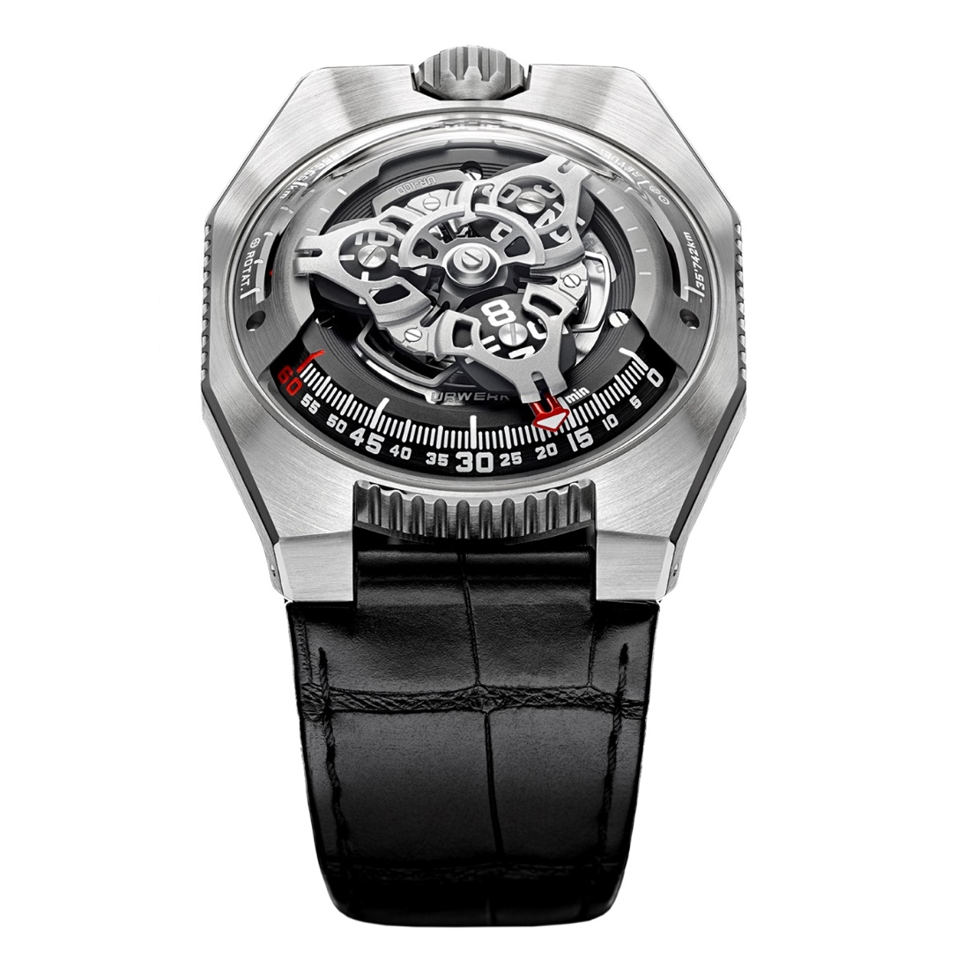

Distance travelled on Earth
The first indicator at 10 o’clock evaluates the distance in kilometers that we have travelled on the Earth without even leaving our desks! It is based on the average speed of the rotation of the Earth on its axis at the equator, covering a distance of 555 km every 20 minutes.

Distance travelled by the Earth around the sun
Directly opposite at 2 o’clock, the same hand (well it looks like the same hand, but is actually one of three) continues its journey to another celestial indication featuring the distance the Earth has travelled in its orbit around the sun – a journey spanning some 35,740 km every 20 minutes.
The UR-100 simultaneously presents three different space-time realities, providing a thought-provoking reminder of our voyage through time and space.
“For me, watches have a philosophical dimension. They are a physical and abstract reproduction of our situation on Earth, with the dial representing the equator, simultaneously in constant motion while seemingly stationary for us,” says Martin Frei, chief designer and co-founder of URWERK.
Felix Baumgartner, master watchmaker and the other co-founder of URWERK agrees: “We live in a universe governed by three dimensions — time, rotation, and orbit — that we attempt to measure and master, but what escapes us is this notion of spacetime.”

Caliber 12.01
Powering the UR-100 SpaceTime is the automatic Caliber 12.01, with baseplates in ARCAP and a power reserve of 48 hours. The automatic winding rotor is regulated by a flat turbine, the Windfäng (Swiss German for “air trap”) that minimizes shocks to the rotor bearing and reduces over-winding and wear and tear. The rotor, which is partially supported on its periphery by the flat turbine, also has a larger diameter, resulting in a lower mass and therefore less wear.

In-house testing of the flat turbine rotor regulation system found that it provided significant and exponential protection against excessive rotor speeds (the Windfänger rotates six times for every rotation of the winding rotor).
The design and construction of the URWERK Caliber 12.01 required incredibly high precision because of the extremely tight tolerances between the minute hand and three different dials and domed sapphire crystal it passes between.
The shape of the case may remind URWERK aficionados of the aesthetics of the brand’s early watches. As Martin Frei explains, "Towards the end of the 90's, we unveiled the UR-101 and UR-102, the UR-100 is a little like our ‘Back to the Future.’ We broke down our approach and used some of the original design elements of our early constructions. The case of the UR-100 is a deconstruction of an early URWERK case. The steel dome of our historic models is reproduced in sapphire crystal. The form is emphasized by the titanium and steel case. I constantly question the diktat of symmetry and played with proportions to catch the eye."

Genesis
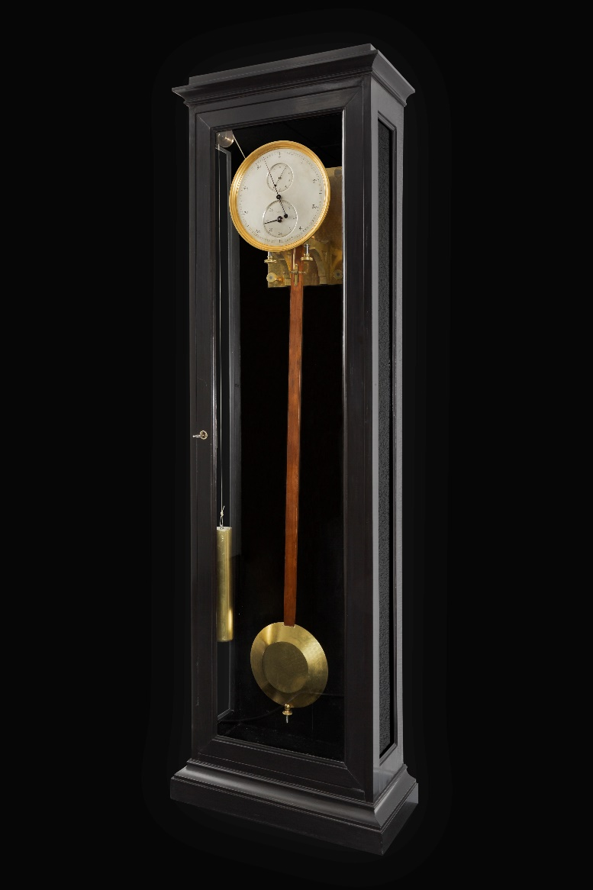
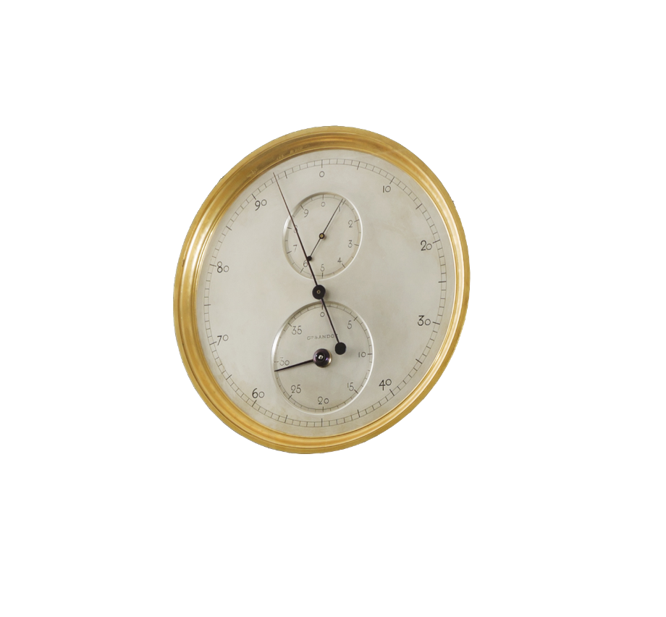
The URWERK UR-100 was inspired by a nineteenth-century pendulum clock — a present to Felix Baumgartner from his father Geri, a now-retired renowned clock restorer — made by Gustave Sandoz for the 1893 World’s Fair in Chicago.

The regulator-style dial does not show time. Instead it shows the distance of the Earth’s rotation at the equator. The extra-long pendulum beats every 2.16 seconds, making every oscillation one kilometer. The main dial has a scale of 10,000 kilometers, shown in units of 100 kilometers, so that each tick (half oscillation) indicates 500 meters traveled on the Earth’s surface (at the equator). The top subdial (10 km) is divided into 10 units, while the lower subdial showing a total of 40,000 km — approximately the equatorial circumference of the Earth — is divided into increments of 1,000 km.

UR-100 SpaceTime – Specifications
URWERK presents two introductory editions: the UR-100 Iron (titanium and steel) and the UR-100 Black (titanium and steel with black DLC), both limited to 25 pieces.

Movement
Caliber: | UR 12.01 with self-winding system governed by low-profile planetary turbine minimizing over-winding and wear
Jewels: | 39
Frequency: | 28,800 vph - 4Hz
Power reserve: | 48 hours
Materials: | Orbital satellite hours turning on Geneva crosses in beryllium bronze; open-worked aluminum carousel; triple baseplates in ARCAP
Finishes: | Circular graining, sanding, brushing  Chamfered screw heads  Hour and minute indications in Super-LumiNova
Indications | Orbital hours; minutes, distance travelled on Earth’s equator in 20 minutes, distance Earth travels around the sun in 20 minutes
Case
Materials: | Case in black DLC-coated titanium and stainless steel
Dimensions: | Width 41.0 mm, length: 49.7 mm, thickness: 14.0 mm
Glass: | Sapphire crystal
Water resistance: | Pressure tested to 3ATM (30m)
Price | CHF 48,000 (Swiss francs / tax not included)

ABOUT URWERK
“We don’t try to bring out yet another new version of existing complicated mechanisms,” explains watchmaker Felix Baumgartner, co-founder of URWERK. “Our watches are unique because they are all designed as original works, which makes them rare and priceless. Our main aim is to go beyond the traditional horizons of watchmaking.” The original styling of each URWERK model is signed by chief designer Martin Frei, the company’s other co-founder. “I come from a background where creativeness has no limits. I am in no way prisoner of the traditional constraints of watchmaking, and I can therefore be freely inspired by my cultural heritage.”

Felix Baumgartner, a watchmaker like his father and grandfather, has time running through his veins. A graduate of the Solothurn watchmaking school, Felix learned the secret language of minute repeaters, tourbillons, and perpetual calendars at his father’s bench.
Martin Frei is the artistic counterpart to his partner’s technical expertise. Accepted into Lucerne’s college of art and design in 1987, Martin delved into every form of visual artistic expression from painting and sculpture to video, emerging as a mature artist. The two men met by chance and discovered a common fascination with the measurement of time, spending hours analyzing the gap between the watches they saw in the shops and the vision of their future creations.

While URWERK is a youthful company established in 1997, it is regarded as a pioneer of the independent watchmaking scene. Producing just 150 watches a year, the company sees itself as an artisanal studio where expertise coexists with avant-garde styling. The company manufactures modern, complicated, and unprecedented watches that are still in keeping with the most demanding criteria of fine watchmaking: independent research, expressive design, advanced materials, and handcrafted finishes.

The name URWERK comes from the ancient city of Ur of the Chaldees in Mesopotamia, founded nearly 6,000 years ago. It is here that the Sumerian inhabitants first established units of time based on the shadows cast by its monuments. “Ur” also means “primeval” or “original” in the German language, while “Werk” can mean either an achievement or a mechanism. Therefore, “Urwerk” can be translated as an original movement — a tribute to generations of watchmakers whose work has resulted in what we know today as haute horlogerie, or superlative watchmaking.

