The Raging Gold UR-105

Geneva – October 2016
Martin Frei, URWERK’s co-founder and designer is also a self-confessed victim of the lure of gold: “There’s always this little inner voice that reminds me how much I love this metal. Beyond the march of technology, changes in fashion, new functions, new materials; gold is always gold. It’s forever. It’s the metal that lights me up.” The designer’s infatuation for the noblest of materials that lives forever without a stain on its glory is how the UR-105 Raging Gold came to be. A shield of red gold carved in an intriguing pattern serves as the bezel on a titanium case.
“Once again, we try to engage all your senses,” explains Felix Baumgartner, URWERK’s co-founder and master watchmaker. “Our UR-105 “Raging Gold” should not only be a pleasure to look at, but a pleasure to touch. The lines and the texture of the case go back to classic principles. The pattern derives from the hobnail motif "Clou de Paris" that was popular in high-class watches. It's a little bit like my "Madeleine de Proust". Embed this little touch of history in a disruptive model gets me a thrill from bringing a conservative style to a revolutionary watch.” confesses Felix Baumgartner, master watchmaker and co-founder of URWERK.
Technically, the UR-105 works on the fundamental concept of Urwerk’s watchmaking, the wandering hour principle, in which each hour travels in turn across a 60-minute arc. This ancient and more intuitive way of telling the time is made easier by a mask made of PEEK, a semi-crystalline polymer, which hides the hours that have completed their 60-minute patrol. The mask is also superbly decorated in proper traditional style.
This 105 version incorporates the latest developments in Urwerk’s constant efforts to add value to the wandering hour principle. The most intricate part of the mechanism, the carousel, which carries the hours in groups of three on four satellite discs, is hidden. It silently and unerringly brings the right hour to the right place at the right time. “In our earlier models,” recalls Felix Baumgartner, “the satellites were mounted on Maltese crosses and suspended from the rotating arms. We’ve found a way to improve on this idea. You can feel the result in your fingertips when you set the time. There’s no friction, no jolts, just the dance of the satellites. Our efforts have been absorbed into a much more fluid transmission.”

On the back of the UR-105, turbines control the selfwinding system. Switch the lever to FULL and the winding rotor reacts to your slightest movement to wind the mainspring. In the RED (reduced) position, the rotor’s movements are dampened to avoid excessive tension in the mainspring. In the STOP position the selfwinding mechanism is disengaged and the watch can be wound manually with the crown.

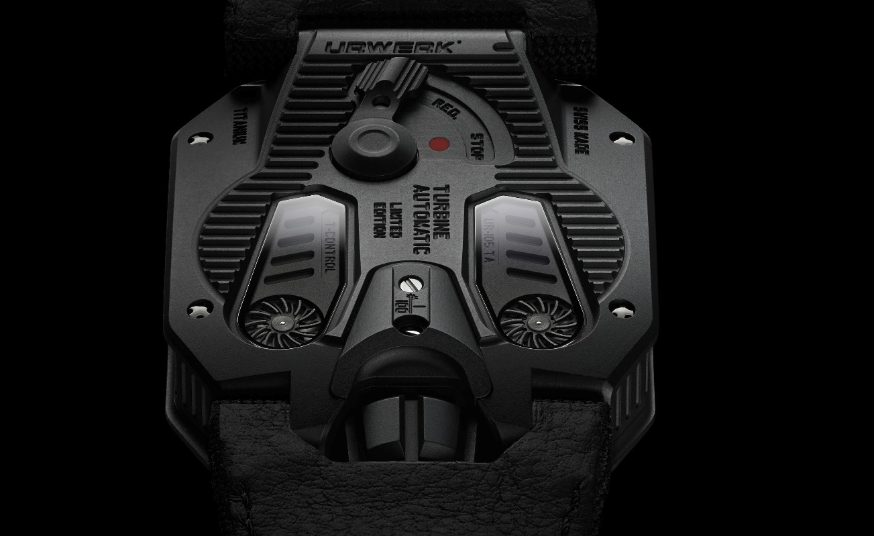

UR-105 “Raging Gold”

Movement
Calibre: | UR 5.02, selfwinding mechanism regulated by a double turbine
Jewels: | 52
Frequency: | 28,800v/h - 4Hz
Power reserve: | 48 hours
Materials: | Satellite hours turned by Geneva crosses in beryllium bronze  Orbiting structure in PEEK (PolyEtherEtherKetone)  Carousel and baseplates in ARCAP.
Finishes: | Circular and straight graining, sanding  Chamfered screw heads
Indications | Wandering hours, minutes. Hour numerals and minutes track handpainted in SuperLuminova
Case
Materials: | UR-105 case 4N gold and the back in titanium with black PVD coating
Dimensions: | Width 39.50mm; length: 53mm; height: 16.8 mm
Glass: | Sapphire crystal
Water resistance: | Pressure tested to 30m/3ATM

___________________

Contact:
Mme Yacine Sar press@urwerk.com
Tel +41 22 9002027 Mobile +41 79 834 4665

ABOUT URWERK

“We don’t try to bring out new versions of existing complicated mechanisms,” explains watchmaker Felix Baumgartner, co-founder of Urwerk. “Our watches are unique because they are all designed as original works, which makes them rare and priceless. Our main aim is to go beyond the traditional horizons of watchmaking.” The original styling of each Urwerk model is signed by chief designer Martin Frei, the company’s other co-founder. “I come from a background where creativeness has no limits. I am in no way prisoner of the traditional constraints of watchmaking, and I can therefore be freely inspired by my cultural heritage.”

Although Urwerk is a young company established in 1997, it is recognised as one of the forerunners of the new wave of watchmaking. Producing just 150 watches a year, the company sees itself as a craftsman’s studio where traditional expertise coexists with avant-garde styling. The company manufactures modern and complex watches that are unprecedented and in keeping with the most demanding criteria of fine watchmaking: independent design and research, advanced materials and handcrafted finishes.

The name Urwerk comes from the ancient city of Ur of the Chaldees in Mesopotamia, founded nearly 6,000 years ago where the Sumerian inhabitants first established units of time based on the shadows cast by its monuments. Ur in the German language also means primeval or original and Werk means an achievement or a mechanism. Thus Urwerk can be translated as an original movement — a tribute to generations of watchmakers whose work has resulted in what we know today as haute horlogerie, or superlative watchmaking.

www.urwerk.com
-www.facebook.com/urwerk

